

In association with
Outdoor Learning UK

OCN Level 3 Forest Schools Award
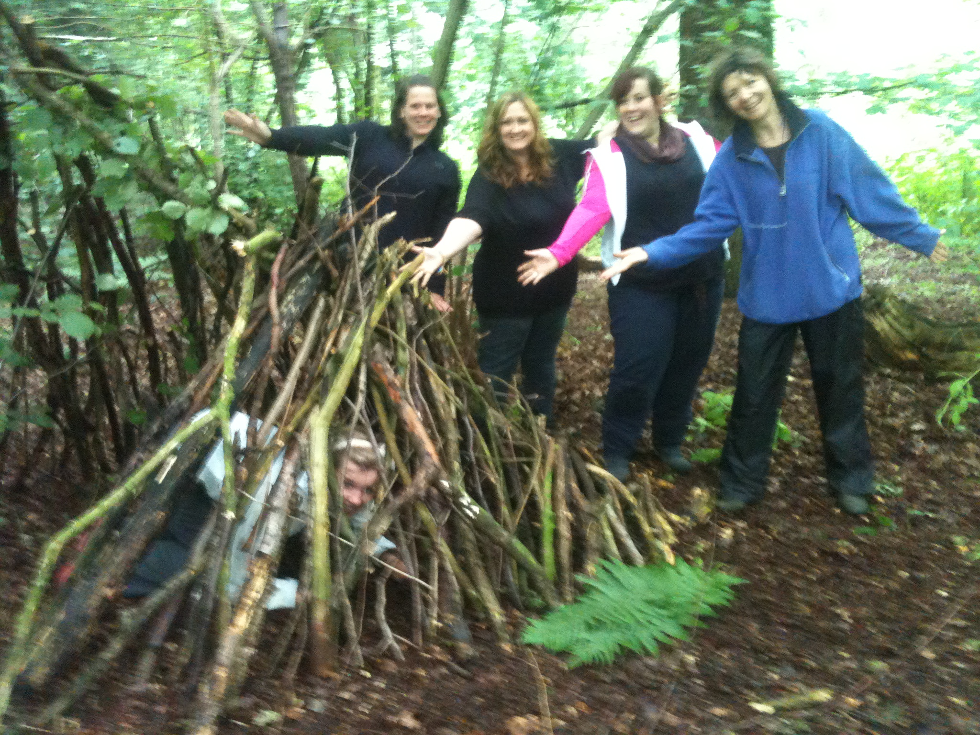
Here at Forest Schools Birmingham CIC, we are more than just a training company, we are a community and a support network. We intend to support you throughout your practice; whether that is help planning a site, support in your setting, INSET, providing supporting practitioners or just a place to ask questions and advice. We are here for the journey.

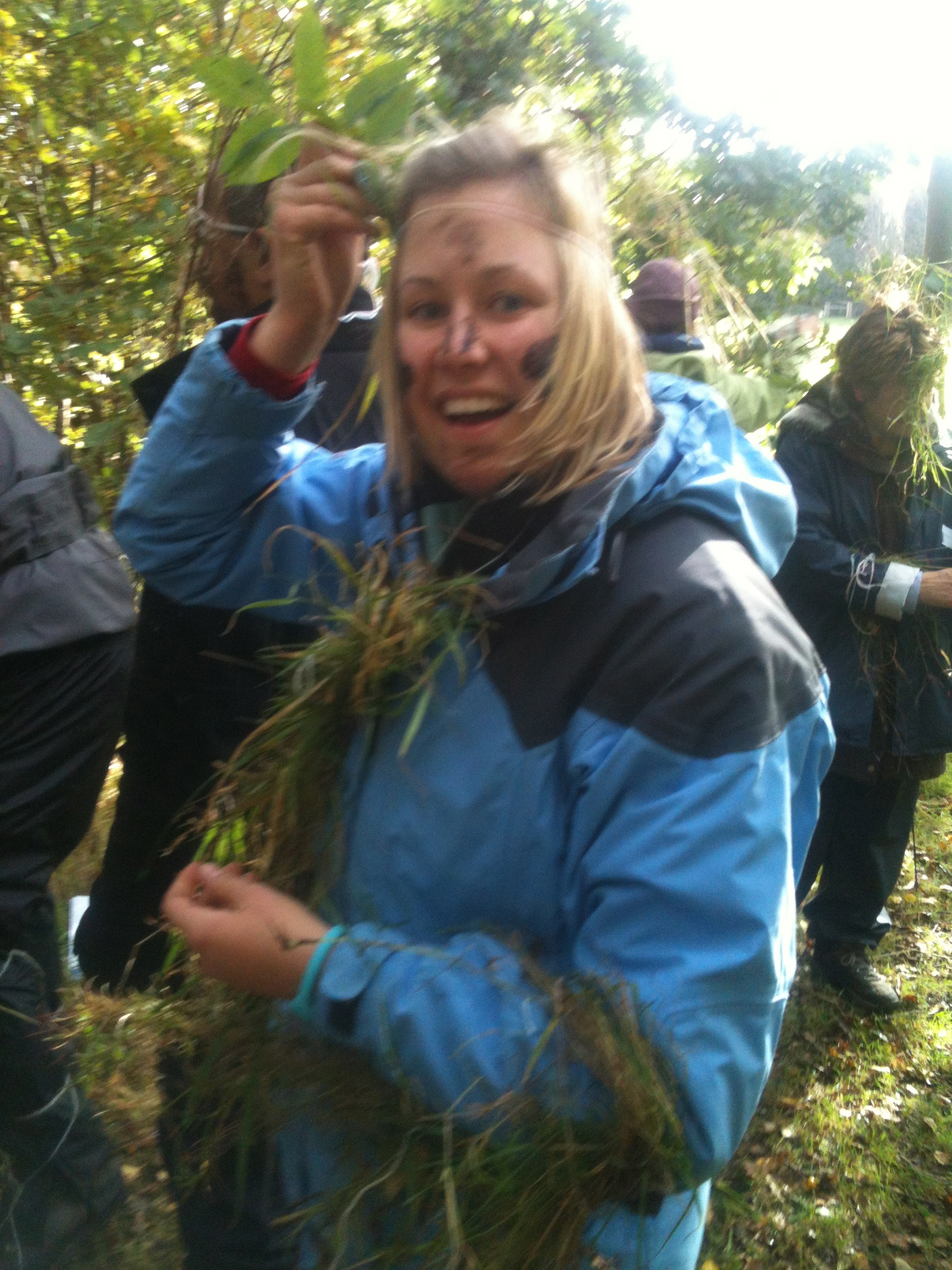

Forest School training is centred around three key areas:

- Supporting the learner’s empathy with the Natural World.
- Scaffolding the child or adult’s coping strategies and underpinning good emotional, mental and physical health.
- Ensuring that the ‘Outdoor Classroom’ is used as often as possible.

Forest School is all about choosing a lifestyle that brings about and sustains positive change.

The Level 3 Forest School training is suitable for individuals who have approximately 2 years experience of working with children in a structured environment and have a love of the Natural World.

You do not have to hold a teaching qualification, this course is suitable for people from a variety of settings.

Our Forest Schools training is of the very highest standard with practical skills and safety at its backbone, underpinned with sound and engaging development theories. Not only are we providers of training, we are also one of the longest standing and most successful deliverers of Forest School programmes to children in the UK. We have worked with 550+ schools over the last 19 years.

We are also an award winning charitable business, having been awarded ‘Birmingham’s Greenest Business’ two years consecutively by the Birmingham Green Commission, Birmingham’s best Food Growing Project, we were invited to Downing Street as part of the Prime Minister’s Big Society Vision and we are featured in The Parliamentary Review 2020.

Training consists of a 5 day initial training period, a personal development and portfolio period of 6 months, and ends with a 5 day assessment. You will then have a further 6 months to finish your portfolio.

In order to complete this training course in a ‘stress free’ manner, we suggest you allocate a minimum of 1-2 hours per week over your 12 month training period, in order to practice your new skills and to complete the portfolio of evidence. This is a type of teacher training, so allocating this time to dedicate towards achieving your accreditation is an important part of undertaking this course.

As part of your course, you will have the opportunity to attend online Zoom study sessions to ensure you are on track with your portfolio.

The training is outdoor based where we have you ‘doing’ as you learn; this way our trainees come away with a practical, kinaesthetic working knowledge of all aspects of Forest Schools, including sound practical skills and a thorough understanding of the theories and benefits relating to good Forest Schools practice.

Throughout your 12 month training period, we will keep in touch regularly to guide you through the training. We want to give you help and support along the way, to keep you on track; helping to build your confidence and skills. Our aspiration is that when you complete your qualification, you will feel confident to go out and run your own Forest School programme, for anyone, anywhere!

What our training consists of:

Initial Training Period – Week 1

- Understanding the learning theories which underpin quality Forest Schools practice.
- Applying these theories in everyday practice.
- Site selection, site set-up and woodland management.
- Aspects of sustainability.
- Use of fire in an education setting.
- Safe effective use of tools.
- Risk assessment and health and safety protocol associated with Forest Schools and outdoor learning.

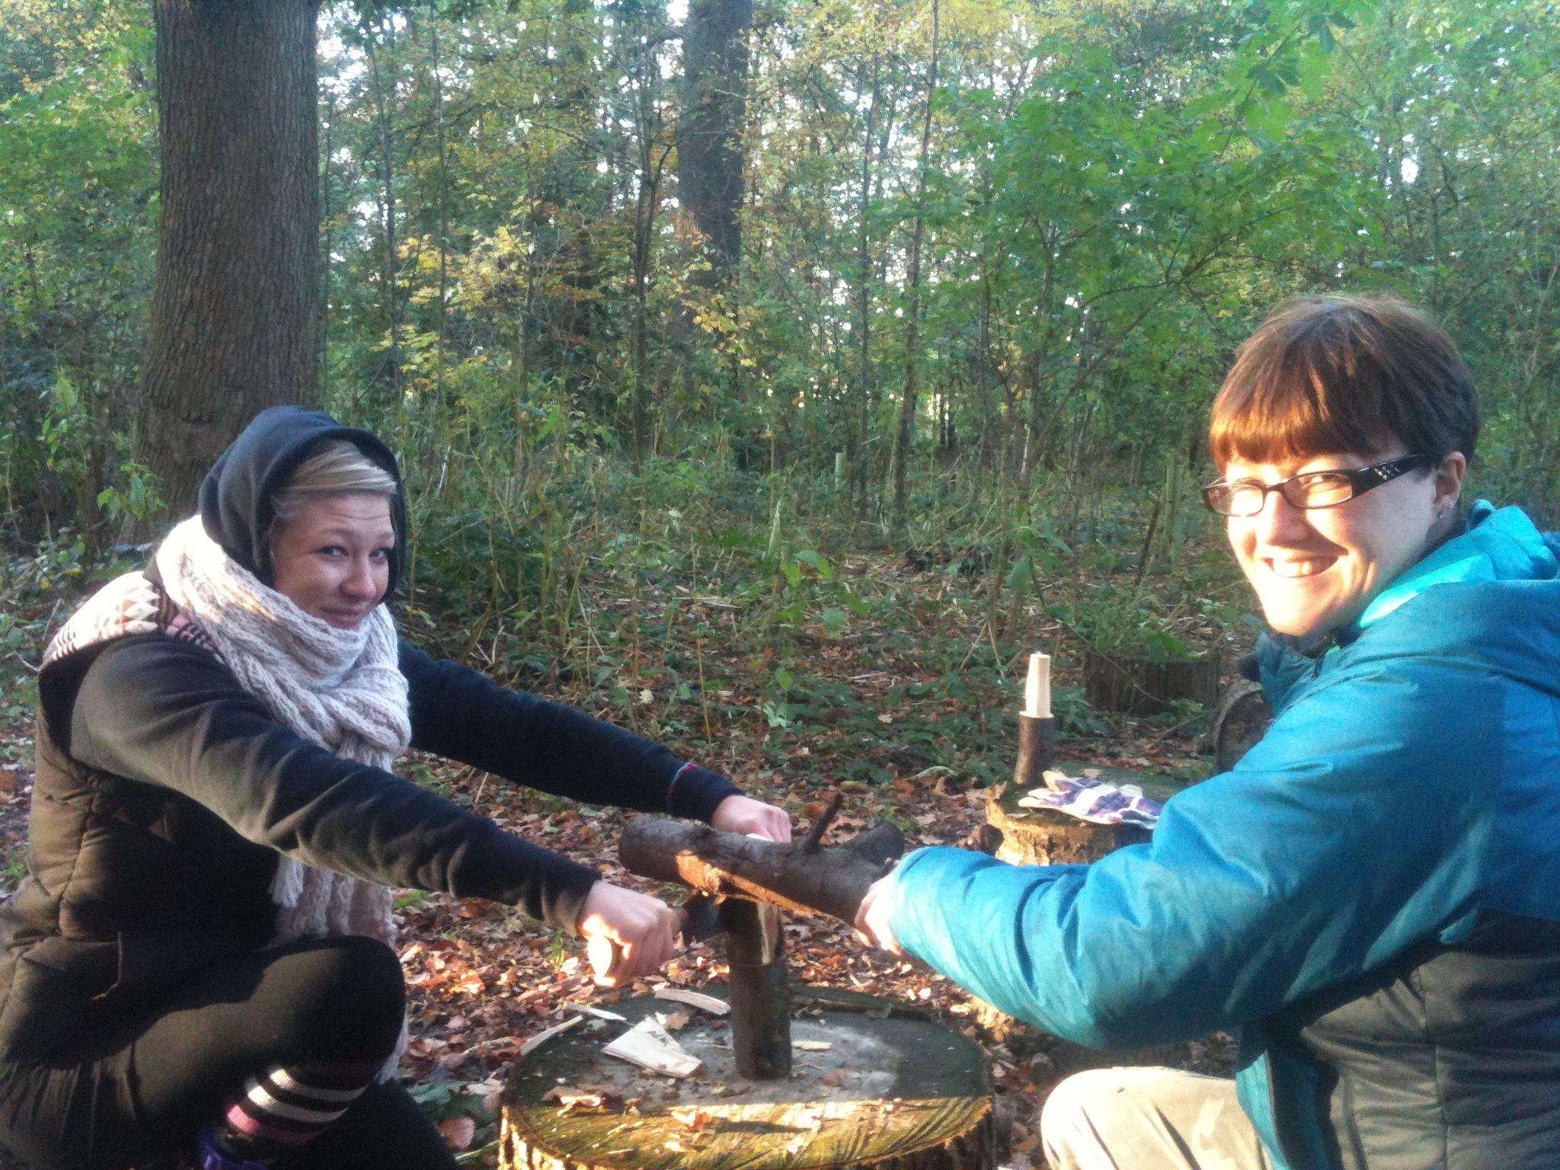
- General management and administration of a successful Forest School.
- Behaviour management.
- Tutorial of portfolio requirements.
- Being successful, engaging and innovative in the outdoors.

Consolidation and Portfolio Period – 6 Months

- Plan, deliver and evaluate a minimum of 6 Forest School sessions employing the techniques outlined in Initial training period.
- Practice, refine and become confident in practical skills.
- Start your portfolio of evidence

Assessment Training Period – Week 2

- Assessment across all practical applications of forest schools; including tools, fire, ethos.
- You will be required to plan and deliver a Forest School session on which you will be assessed.
- Feedback and portfolio questions.

Please note that in order to complete your qualification; you must hold an Outdoor or Forest School Paediatric 1st Aid Certificate. We offer this but you can do this with any training provider.

ALL INDIVIDUALS WORKING WITH CHILDREN, YOUNG AND VULNERHABLE PEOPLE MUST HOLD A VALID ENHANCED DBS

